Bash script -02

1. Create a bash script to check if a directory is available or not.
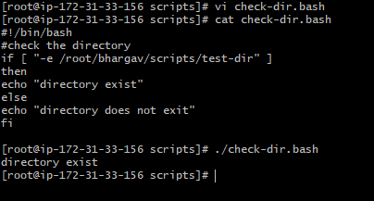

2.Create a bash script to create multiple files.
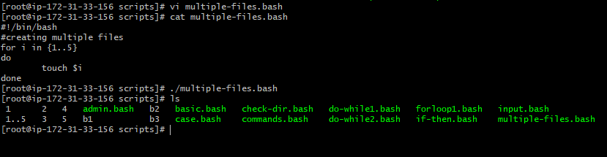
4. Create a bash script to install Nginx on an EC2 server.
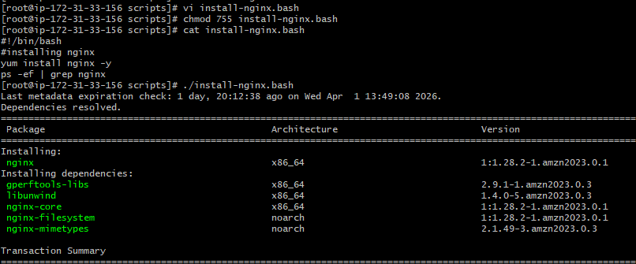
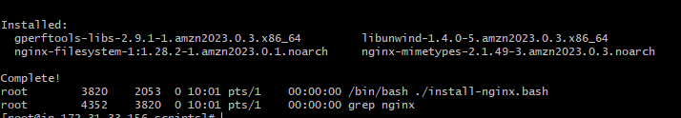
6.Create a bash script to install Apache Tomcat on an EC2 server.
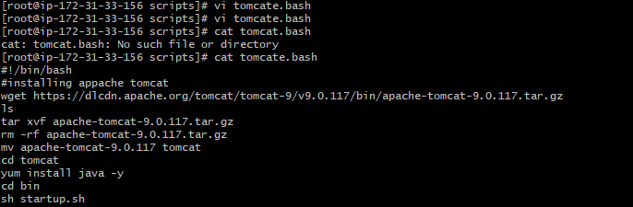
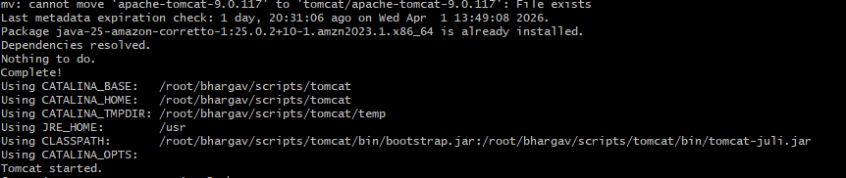
Create a bash script to check if the Nginx service is running, if not running then script should start the service.
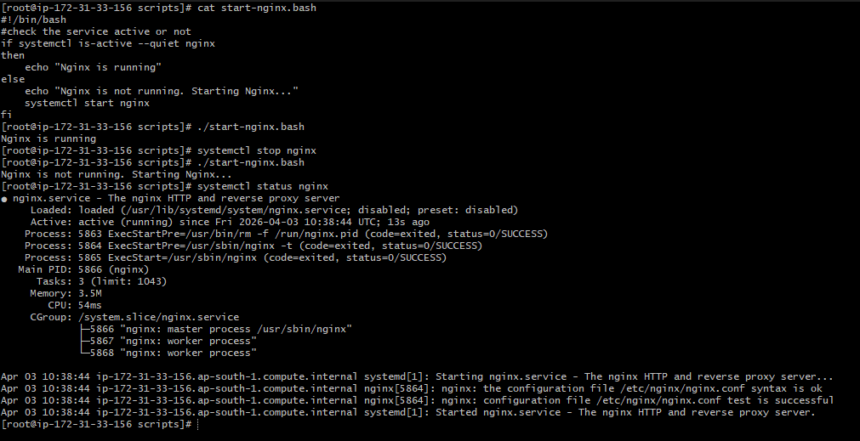

Create a bash script for a calculator.
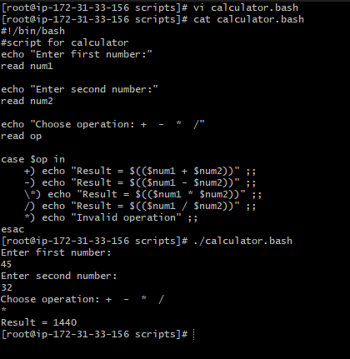

Create a bash script to check if a directory exists, if not then create a directory.
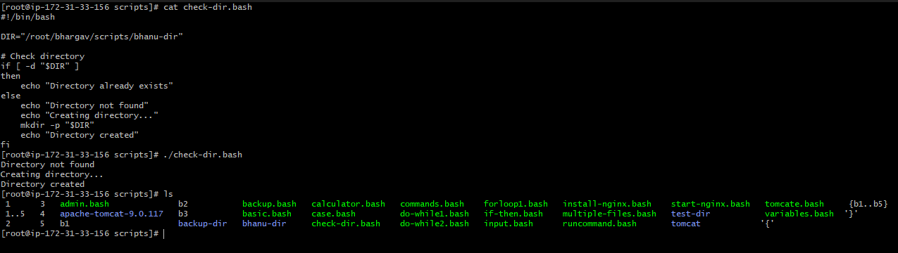

Create a bash script to delete the last 3 lines of a file.
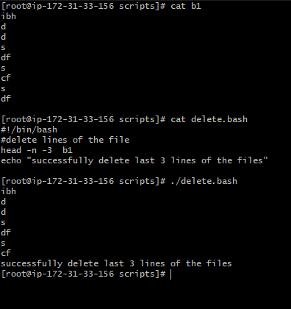
Bash script to monitor cpu and if it is more than 50% then send email notification.
first we have to install mailx service and do some configuration on /etc/mail.rc file
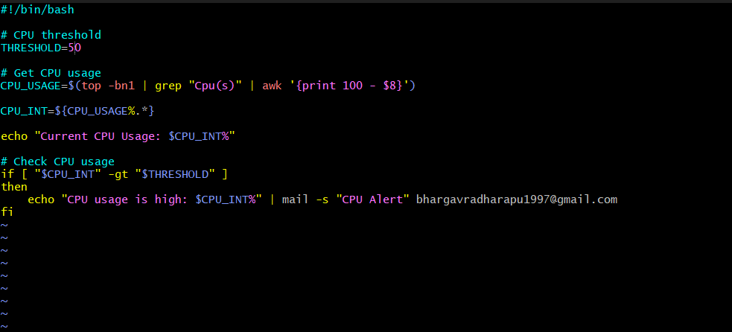
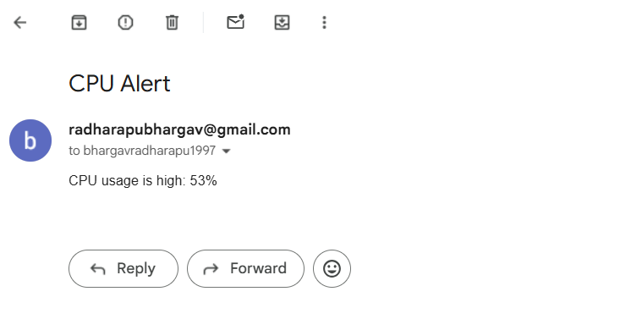
Bash script to monitor disk space and if it is more than 20% then send email notification
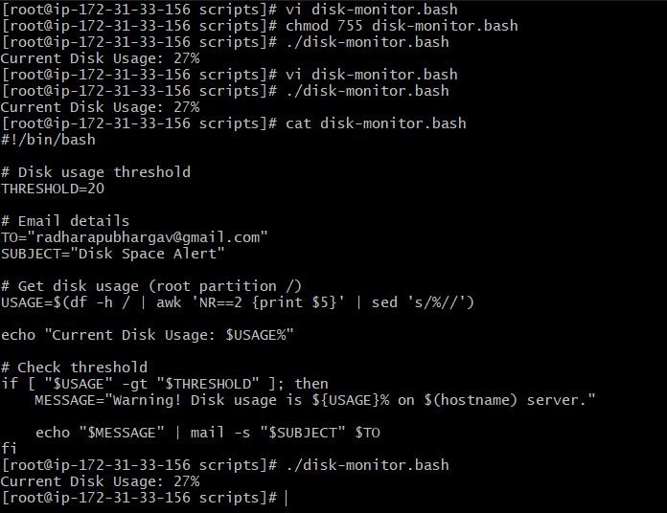
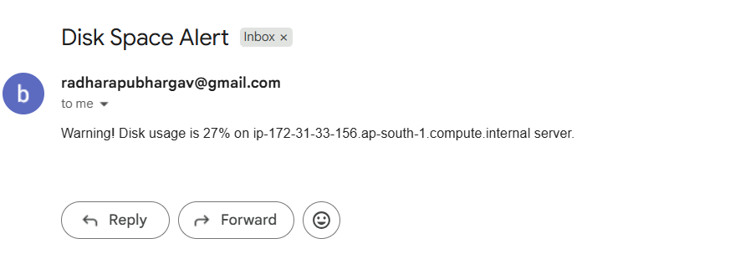
Bash script to monitor memory and if it is more than 30% then send email notification.
